Exercise about installing a second operating system:

As in the other exercises, we will need a Virtual Machine to install the two OS or if we already have a VM with one OS we are going to use it, as in this case:

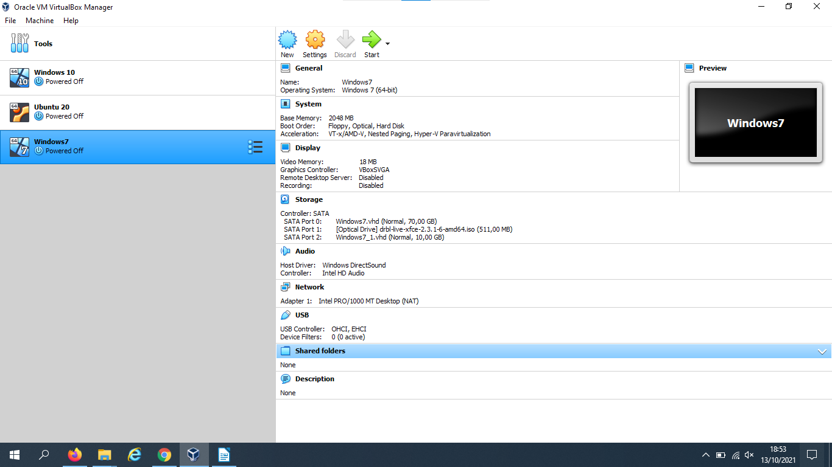
We already have the 70 GB Harddisk, so we start installing the Windows 10 OS, as we already know on the optical unit, then Choose a file and then selecting the ISO file and finally OK.

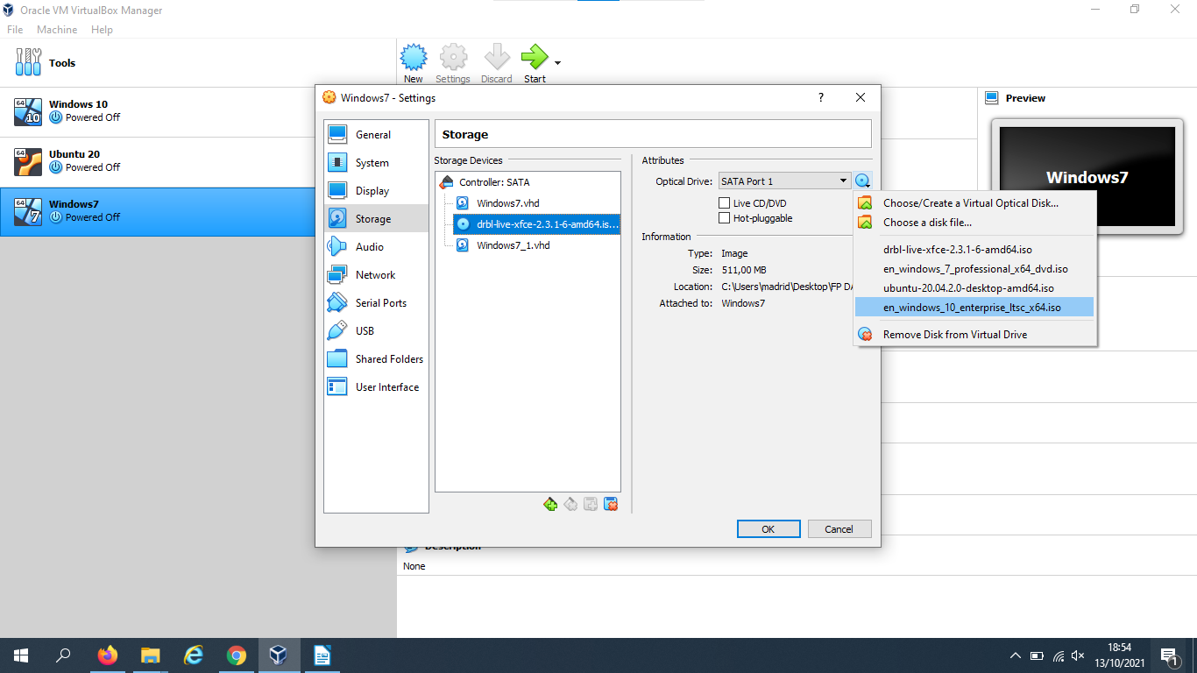

And you will start the installation process:
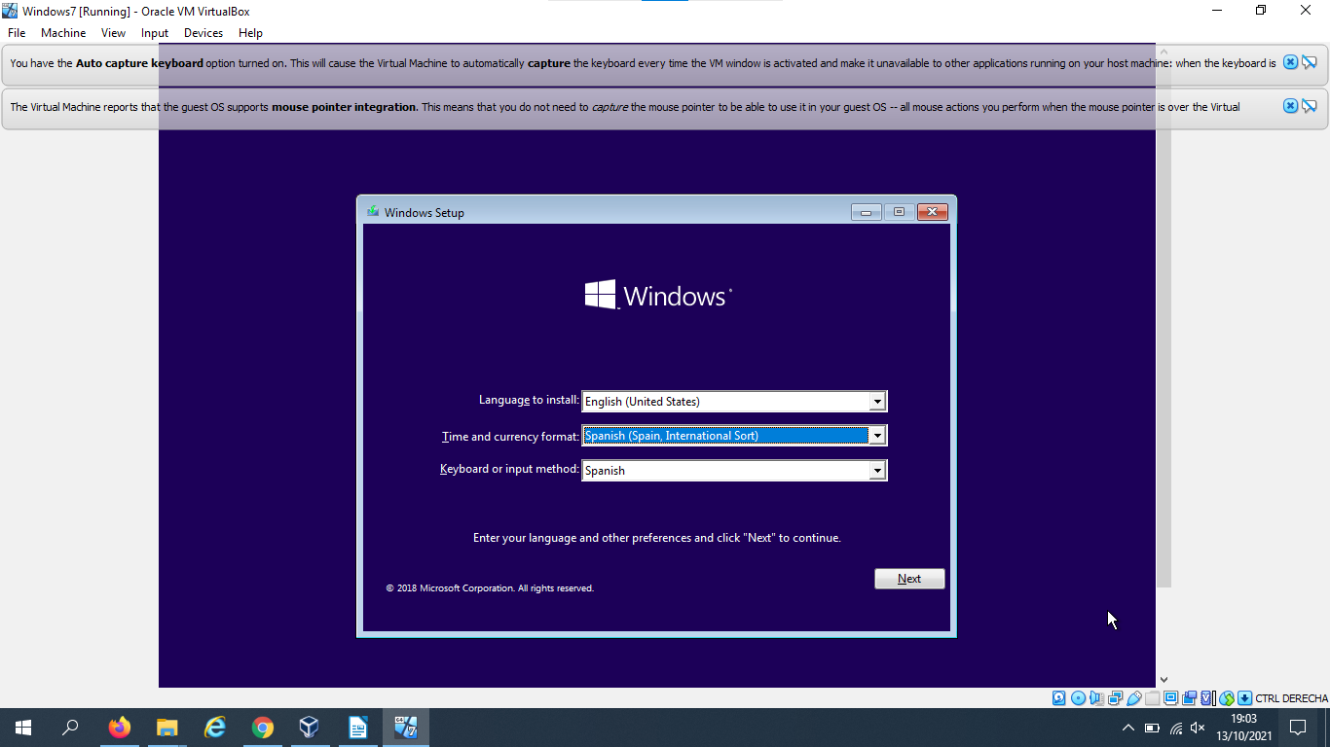
You choose the first option:
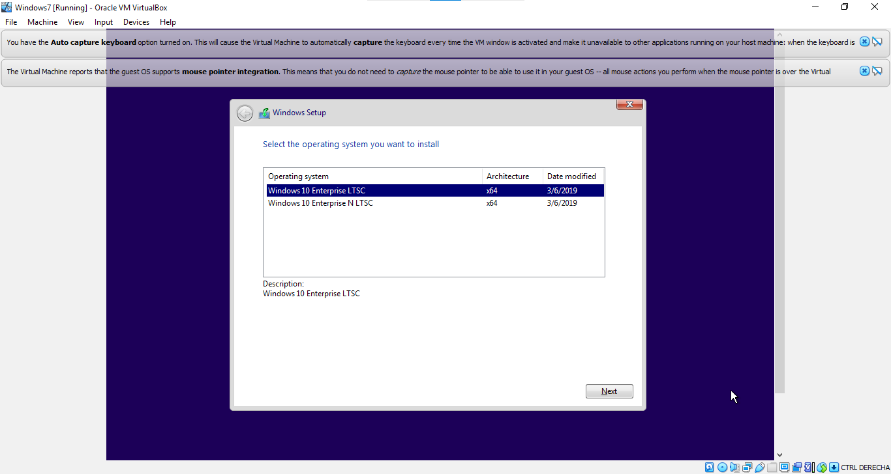

Then you choose the Unallocated space:
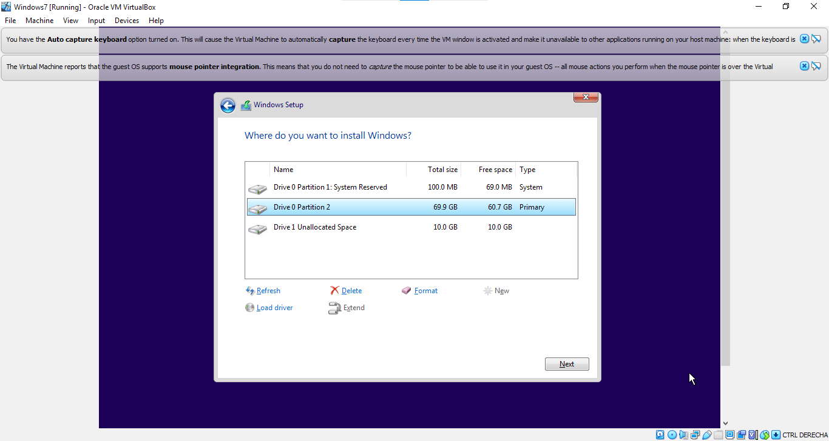
And Windows start to installing:
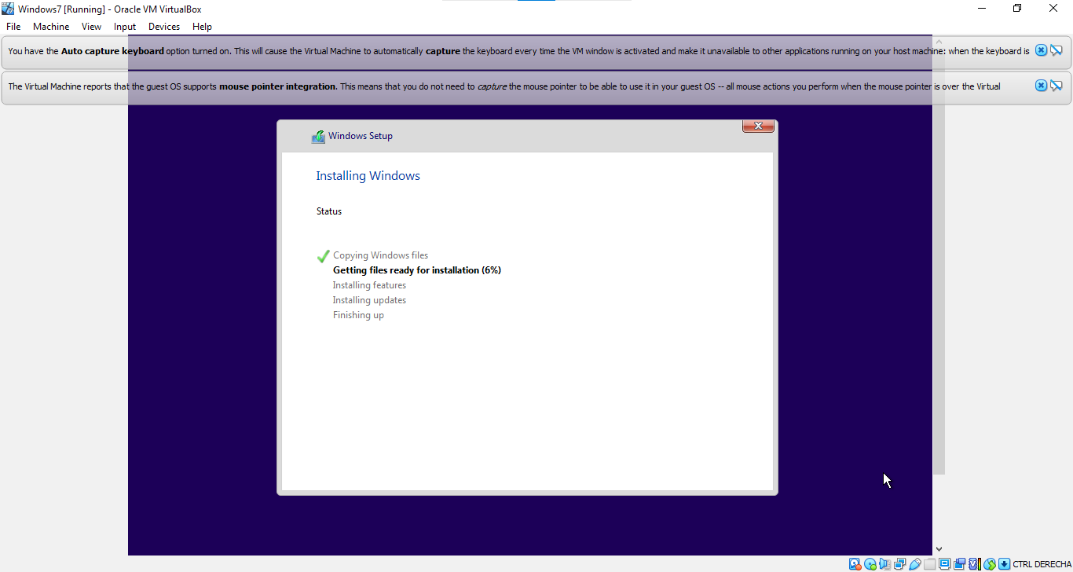

Once Windows finish to install, your screen will see like this:

